Project of social advertising of sustainable consolidation, promoting the elimination of grass burning practice and explaining the negative consequences of grass burning for the climate, nature, economy and people health

“The grass burning is..”
The authors of the idea: the ISEU Public Campaign “Just stop the grass burning!”

International Socio-Ecological Union (ISEU)
7 October 2018

SUMMARY

The proposal of social advertising of sustainable consolidation “The grass burning is..” (later the “Proposal”), informing about the negative consequences of dry vegetation burnings on natural and agricultural lands for the climate, wild natural ecosystems, soils, economy and human health in the form of individual emotionally colored examples. The proposed social advertising aims to eliminate the tradition of unauthorized (illegal) forms of grass burning, which are the most dangerous for the environment and people.
The coordinators of the ISEU Public Campaign “Just stop the grass burning!” http://www.green-forums.info/antifire/ (later Campaign) are the authors of the Proposal and all its ideas. All author’s rights to the Proposal and all its ideas belong to them.
The Proposal is located in the Internet to promote its spreading and free use of its ideas by everyone. The moral and material benefits for potential performers of the Proposal are given. The wide spreading of the Proposal among potential performers and all people who are interested in solution the problem of catastrophic wildfires is welcomed.
About the ISEU Public Campaign “Just stop the grass burning!”
The Campaign was launched in 2016 by Russian environmentalists to fight against the grass burning tradition in Russia. The grass burnings every year become the main reason of wildfire catastrophe in this country. Wildfires are lunched by unauthorized (illegal) grass burning and, frequently, by legal prescribed burning, implementing for agricultural purposes and forest fires protection.
The main focus of the Campaign is the fighting against unauthorized grass burning (prohibited by law in Russia), which people conduct in vast areas at spring and autumn seasons. Those grass burnings give the largest percentage of wildfires in most regions of the country.
The Campaign also works to reduce the area of “legal” prescribed burning, which are allowed to be implemented in forests lands for prevention them from fires. The regional government in Russia annually appoint such a large area of prescribed burning that they are impossible to conduct using the methods of burning control recommended by specialists and set by law. Because of this, the prescribed burnings in forest lands are frequently conducted without appropriate control. As a result they themselves often lunch of strong forest fires.
In 2015, the agricultural grass burning was prohibited by law across the entire Russia, but many farmers still continue to burn. The third focus of the Campaign is fighting against agricultural burning: the search of alternatives of burning of crop residues and straws, which would be understandable and convenient for farmers.
In total, all forms of burning give annually more than 90% of the causes of wildfires in Russia (forest fires, peat fires, grass fires, steppe fires and reed fires). The remaining 9-10% are caused by other forms of careless handling with fire in natural areas, like campfires which were not extinguished completely, smoldering cigarette butts thrown on dry grass, improper burning of garbage in garden areas, sparks from cars. The natural causes of wildfires can be only thunderstorms without rain (dry thunderstorms), but they are extremely rare in Russia. Almost all wildfires are caused by human actions.
Since July 2017 the Campaign “Just stop the grass burning!” has been operating as the public campaign of the International Socio-Ecological Union (ISEU), http://www.seu.ru/, http://int.seu.ru/, which one of the oldest Russian environmental organization and the only international environmental organization which was born in USSR. From this year the Campaign started steps towards international character of work, because we saw that many countries of the World also have the problem of massive burning of dry vegetation and all negative consequences of these actions, the main of which are the frequent catastrophic wildfires.
Countries that conduct dry vegetation burning on vast areas for agriculture, forestry, and fire prevention purposes, and at the same time which have huge wildfires quasi every year are: Canada, United States of America, Australia, Russia, Argentina, several European countries (Portugal, Greece, Spain, etc), Indonesia, several African countries.
Countries that conducted dry vegetation burning in the past, but then stopped doing it, and after that the forest fires there had significantly reduced: Finland, Sweden, Germany, New Zealand.
In many countries where the grass burning is still carried out, the problem of this practice and its connection with wildfires (and other negative consequences) is still poorly understood in society. The environmental organizations, activists, scientists and press don’t speak loudly about that. As a result, the society of the most countries has low level of awareness about the problem of dry vegetation burning and the risks of this practice. For example, a lot of people do not know that the authorities of their country conduct the prescribed burning (the intentional burning of dry vegetation like grass, crop residues and straw on fields, grass, branches and dry trees in the forests) on large areas. When people find out about that (especially if this country has annual catastrophic wildfires) they come in horror. The logical connection between burning of dry vegetation in natural and agricultural lands, the potential danger of this practice especially in dry and windy climate and the annual heavy wildfires is obvious for any rational thinking person.
The objectives of the international work of the Campaign are the follows:
- To stop all forms of unauthorized (illegal) grass burning. Due to the fact that those burning are implemented mostly by non-professionals without appropriate means of control (often they are conducted intentionally without control) – they often lead to strong wildfires, so they have the greatest danger to environment and people.
- To implement a wide information coverage and popularization of the whole problem of the dry vegetation burning:
2.1 To inform people about existent types of unauthorized illegal grass burning and legal prescribed burning and areas of burnt lands in each country (the dry vegetation burnings are usually conducted for the purposes of agriculture and forestry, protection of forests from wildfires and for others reasons, including, not rational ones).
2.2 To inform about all potential risks and proven negative consequences of all forms of dry vegetation burning on wildlife, climate, agriculture and public health.
We believe that public awareness of the dry vegetation burning practice will lead to development of critical attitudes and public distrust to all forms of grass burning. This, in turn, will contribute to the consideration of the problem of grass burning at the state, scientific and public environmental level. This can trigger the implementation of objective scientific researches focusing on the impact of grass burning on soil, native ecosystems, climate, and people’s health.
3. To insist on conduction of objective scientific researchs studying the impact of legal prescribed burning and unauthorized grass burning on strength and frequency of wildfires, quality of soils, native natural ecosystems, climate, people health and economy. To insist that those researchs should be implemented by independent specialists in objective and comprehensive manner and should not based on the accepted paradigm of the unconditional benefits and safety of prescribed burnings.
Here the following arguments should be used. Any strong human intervention in Nature is always harmful, unless the otherwise is proved. For this reason, it is not the opponents of the prescribed burnings must prove their danger and harm to environment and people, it is those who promote this practice and conduct the dry vegetation burnings on vast areas must prove their SAFETY and their NECESSITY.
However, the evidence of various harmful effects of dry vegetation burning is obvious and lies on the surface. Although the opponents of dry vegetation burning do not have to prove their negative consequences, but they can easily prove them. For do this, only the basic scientific research of the influence of dry vegetation burning on the environment, climate, people health and economy should be conducted.
These researches have not been conducted anywhere, in spite of they are necessary for using such a strong human intervention in Nature as frequent burning of dry plants on vast areas. We suppose that they have not been implemented for the reason that in the countries where the prescribed burning is widely used, the scientific paradigm of their unconditional benefit and safety exists. (A paradigm - is a well-established scientific concept, which is not questioned in society, over which scientists and all other people do not think critically and do not ask question – is it true?.). The science of these countries has never set a goal to objectively estimate the impact of dry vegetation burning on the scale and frequency of wildfires, on the quality of soils of agricultural fields, on changes in natural native ecosystems in which the prescribed burning is conducted to protect them from fires, on the health of people. And, finally, on all economy of the country which every year spends a lot of money to carry out prescribed burning, and then even more money – to extinguish of strong wildfires, which most likely were launched by legal prescribed burnings or illegal unauthorized grass burning. The volume of the last one directly correlated with the volume of the first one, because ordinary people frequently see the “bad examples” of wide application of vegetation burning for different needs, which stimulate them to burn by themselves. For example, in wildfires season some people may want to protect their private lands from wildfires by implementation of grass burning by themselves, nobody control them in their own lands… as a result those actions will provide new strong wildfires.
We believe that when the objective and comprehensive scientific researches of all negative effects of the dry vegetation burning in natural and agricultural lands will be implemented, the conclusions that the burning practice should be stopped will be clear to government and population of each country.
The multiyear period of burning of dry vegetation has already led to significant changes in natural ecosystems (the most striking example is Australia). For this reason – the refusal of burning for the first time may produce greater wildfires in some regions.
The position of the Campaign - it is necessary to change the attitude to dry vegetation burning and to go to complete termination of this practice. For which it is necessary to develop transition programs (perhaps to make the refusal gradual), to involve scientific research in this topic.
* * *
The proposed social advertising is aimed to eliminate the unauthorized (illegal) forms of grass burning. It is not aimed directly to eliminate the legal prescribed burning, to get rid of which the society should be brought by more complex measures. However, it will be important for this purpose, as it will constantly remind people about what all forms of dry vegetation burning mean, what negative consequences they have.

GENERAL STATEMENT
Target audience
The main target audience of the proposed social advertising is children of school and preschool in age from 5 to 17 years old. In a lesser extent, the target audience is adults who will be exposed to social advertising directly through their children and all other people who will use products with the proposed social advertising.
Objectives
The objectives of the proposed social advertising to transmit information among school children and adults about the negative consequences of grass burning for the climate, wild nature, economy and human health in an unobtrusive, well-remembered form as individual emotionally coloured examples.

The proposed social advertising aims to eliminate the tradition of unauthorized and illegal forms of grass burning and prescribed burning on natural and agricultural lands.
Expected results
The proposed social advertising aims on children’s and adult’s comprehension and remembering of the negative consequences of dry vegetation burning in natural lands. The expected result of the long-term use of this type of social advertising - is formation of negative attitude to grass burning in people, who will be aware of the various negative consequences of dry vegetation burning for the climate, nature, people health and economy and, for this reason, will not burn of grass by themselves and will prevent those actions from other people. The practical expected result is a significant reduction or elimination of unauthorized and illegal grass burning in natural and agricultural territories in a region where the proposed social advertising will be used. The effectiveness of the proposed social advertising will be enhanced in case of implementation of other educational measures aimed to finish the tradition of illegal grass burning.
The author’s right of the idea of the proposed social advertising
The coordinators of the ISEU Public Campaign “Just stop the grass burning!” http://www.green-forums.info/antifire/ (later Campaign) are the authors of the Proposal and all its ideas. All author’s rights to the Proposal and all its ideas belong to them.
The authors give a free opportunity (without payment and notification of authors) to use the Proposal in a whole or partially to perform of social advertising against any form of dry vegetation burning. The only condition of use: everyone who will implement the project of social advertising basing on the Proposal cannot limit the possibility of implementation of a similar project for anyone else in the World (i.e. cannot take copyright over an idea and limit the repetition of a similar idea by anyone else).
The Authors are ready to provide advice and possible assistance to the performers in all the steps of the implementation of the proposed social advertising in their administrative region or a country. The contacts are given at the end of the announcement and in the “Contacts” page of the website of the Campaign: http://green-forums.info/antifire/contacts.htm
Potential performers
Potential performers of a project of the proposed social advertising in a country or its administrative region are the following:

- Commercial or state companies producing school copybooks, school diaries, children's coloring books, matches, newspapers.

- Artists who will be able to draw a series of pictures in the style of children's comics “The grass burning is..” (general ones and with regional differences) necessary for implementation of the proposed social advertising.

- Environmental public organizations that will be able to launch the project creating the proposed social advertising in their administrative region or a country.

- State programs and their coordinators aimed at solving environmental problems in priority regions, which would be able to implement the project creating the proposed social advertising within the framework of their tasks.

- Reserves and national parks, which would be able to coordinate the implementation of the project creating the proposed social advertising in surrounding territories.

- Public and private foundations that could provide financial support and open a competitive grant for implementation of the project creating the proposed social advertising in an administrative region or throughout a country.
The motivation and interests of the potential performers
The performers of the proposed social advertising may have the following interests:

1. Fighting wildfires (moral interest, concern for the nature and people)
This work will be important contribution to elimination of the practice of dry vegetation burning, which is the important or even main cause of all wildfires.

2. Commercial interest
The involvement of a commercial company in a social advertising with important environmental and social objectives (as the proposed social advertising has), will serve as a good commercial advertising of their products. For an artist, participation in this project will be a good contribution to a professional resume.

DESCRIPTION OF THE PROJECT
Technical tasks for implementation of the proposed social advertising

The team of performers needs a common comprehension of the negative consequences of dry vegetation burning and wildfires for the nature, climate, agriculture, human health and economy. They need to create a large series of picture + short signature representing those consequences according to the following design:

1.“the grass burning is”… picture.. “a dead hedgehog”,
2.“the grass burning is”… picture.. “a burnt nest of a blue Jay”,
3.“the grass burning is”… picture.. “my lovely big oak burned near our village”
4.“the grass burning is”… picture.. “my grandmother doesn't have her house anymore”
5. .“the grass burning is”… picture.. “my little brother got sick from the smoke of wildfires”
6.“the grass burning is”… picture.. “the burned young forest planted last autumn by school children”

The idea of the design is: in each individual story to show a single hero suffered because of the grass burning or wildfires (which, in their turn, were caused by grass burning). Some objects can be personalized (my oak, our village, my brother), others ones - non-personalized. The “stories” can be implemented in general way and in relation with the geographic specifics of a region where the proposed social advertising will be applied:
7.“the reed burning is”… picture.. “a burnt nest of a grey heron”,
8.“the reed burning is”… picture.. “my uncle Michael, a fisher, didn’t catch any fish this year for his family because the spawning ground was killed by reed fires in Spring.
Instead of “The grass burning is”, it can be used “The grass burning means…” or any other equivalent.

The created a series of comics should be applied by the following ways:

1. School copybooks and diaries
The created series of comics “The grass burning is..” should be offered for printing on the covers of school copybooks and diaries. A single story should be printed in one place - on the front cover sheet or on the outside cover sheet. It is better to make pictures in a black and white palette in the form of contours (in the style of children's coloring). It will reduce the cost of their printing, and to leave the opportunity for children to paint them.

How it will work. Children in a classroom because of tiredness or boredom often examine what lies on their tables, paint something on copybooks or sheets of paper. Who didn't do it at school?

Therefore, the sense of an individual sad story “The grass burning is...” printed on each copybook or a diary will be unostentatiously remembered by children, written to the depths of their memory. The children will see different stories often (every time, taking copybooks or diary), will paint them and, at the same time, unwittingly think about their sense. Diversity of pictures and related stories will increase the interest and attention of children.

Children passionately love to collect something, love to compare their collections with their neighbour (who has better), love to change, discuss the collection. They can be very unassuming in choosing what to collect. When children notice that everyone in the class has those pictures on copybooks and diaries, but they are different, their interest and attention will increase, they will be able to change, cut and collect the “The grass burning is...” comics or just look them at each other.

We emphasize the importance of the fact that the examples of what is the grass burning are presented as individual stories. People and especially children are much more empathize to a particular hero, a particular creature, about the sad fate they have known. Therefore, suffering of one hedgehog or one hare or one bird’s nest with eggs, which were killed because of grass burning will be much more upset, remembered and penetrate into consciousness than the information on TV about the wildfires on many thousands of hectares of forests, where a lot of hedgehogs, hares, birds and other animals habit.

Many individual sorrowful stories about what the grass burning means will be a good memorable educational material for children, forming a sustainable negative attitude to the burning of grass. This method will allow to children to regret about a specific hedgehog, hare, eggs of a Jay, a fox, a flower, a young wood which were suffered because of the grass burning and wildfires.

Multitude of individual sad examples of the consequences of the grass burning will allow to children to connect this set into a series, that is, to create an understanding of the diversity and scale of the negative consequences of plants burning. Children will reach this unobtrusively, gradually and by their own mind, which is the best way to educate and consolidate the material in memory. This will also motivate to act to protect natural lands from grass burning and wildfires, which can determine the professional choice of children when they become adult. That is, it may lead that more young people will work in groups of volunteer or professional wildfires fighters and protect their lands from wildfires.

2. Matchboxes
It is possible to run the proposed social advertising on matchboxes. For this, a similar series of different pictures and captions “The grass burning is…” or “The grass burning means…” should be created and printed on the matchboxes. For matches the plots of individual stories of the consequences of grass burning can have more adult and tragic character.

How it will work. There's a lot of rationality in this sentence. The grass is often burn by people using matches. People buy matchboxes for household needs and smoking. The various individual stories about the terrible consequences of grass burning printed on matchboxes will led to reduction the grass burning practice among adult people. This will work similarly to the previous method. People looking at the matchboxes will unwittingly understand the diversity and scale of terrible consciousness of the grass burning for the environment.

Probably a project of social advertising on matchboxes can be lunched easier and faster than a project with copybooks and diaries for schools. By this project the proposed social advertising can be started.

3. Badges
The special badges with the same design “The grass burning is…” or “The grass burning means…” can be created and given for free to children and adults on various wildfire protection and nature conservation educative events.
Historical analogues
The proposed social advertising is based on the historical analogues.

The idea of the method of presentation used in the proposed social advertising was taken by analogy from the chewing gum with stickers “LOVE IS” which was popular in Russia in 1990s. Chewing gum was liked by children because of its sticker, on which a funny picture with a signature was printed. Here is what they looked like:

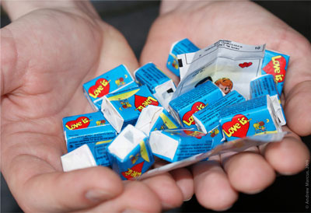

The idea of “LOVE IS” comics appeared in the 1970s in New Zealand. Comics became very popular in many countries. At first, comics were published in black and white palette:

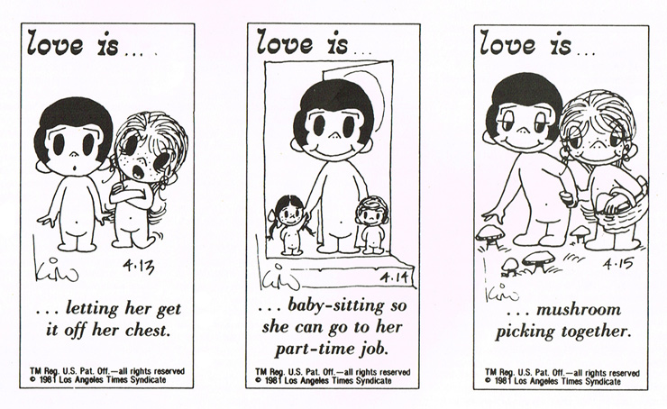
Then the authors of comics started to use a color palette and expanded the range of application of the comics. On the fansite of the comics “LOVE IS” (http://www.loveisfan.com/all-pictures) the variety of pictures and the history of the idea can be found. Some examples of comics “LOVE IS” on stickers of chewing gum:

Love is…  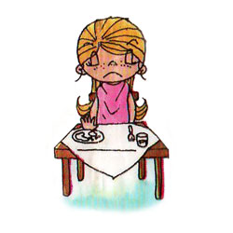  losing appetit | Love is…  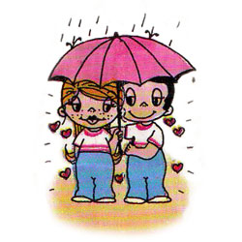  the sun shining bright in a rainy day
Love is…  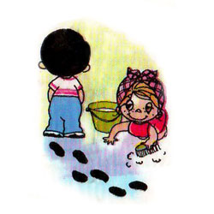  being able to keep cool when he makes the floors dirty just after you have cleaned them. | Love is…  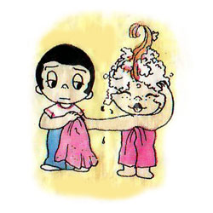  giving her the towel when her eyes are filled with shampoo.

It is important to say that despite of similarity of the method of presentation, the proposed social advertising will not violate the copyright of comics “LOVE IS”. The pictures and their heroes, the plots of individual stories, the sense of signatures, the entire thematic sphere and the method of subsequent application – will be completely different. But just in case, in September 2018, the authors wrote to the brand “LOVE IS” and described the proposal of social advertising with the question – do they see any violations of their copyright? No response was received: http://forest.ru/forum/messages/forum18/topic649/message1471/#message1471

In fact, the common word here is the only word “is”, which cannot be considered as violation of any copyright. But if performers of the proposed social advertising will still worry about that they can:

1)Contact with the “LOVE IS” comics by themselves and ask them a similar questions about copyright.

2) Use the phrase “The grass burning means” instead of “The grass burning is”, which will deprive the design of the proposed social advertising of the last similarity with the design of the brand "Love is".

There was a historical analogy of the proposed social advertising in the sphere of nature conservation itself. In Russia in the early Soviet period in order to teach children not to destroy of bird nests, the educational pictures about the bird’s protection were printed on school copybooks. By the similar way the days of tree planting (special school holidays, when people went out to plant new trees within towns and parks) were popularized among children and adults.

Contacts of the authors:

- Novoselova Natalia - Coordinator of the Public Campaign of ISEU “Just stop the grass burning!”
website: http://www.green-forums.info/antifire/, email: antifirecamp@gmail.com
- Zabelin S. I. - The chairman of the council of the International Socio-Ecological Union (ISEU), website: http://int.seu.ru/

